Prometheus Monitoring Setup on Kubernetes

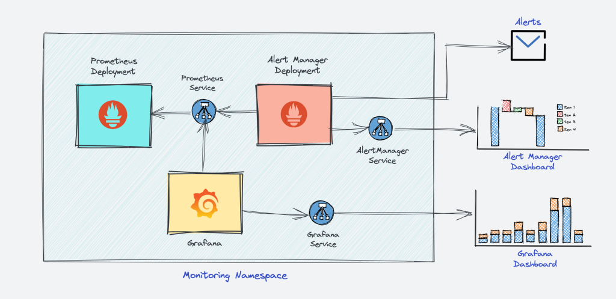

Connect to your Kubernetes cluster

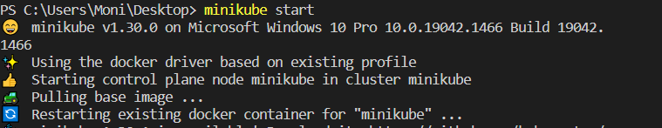

Get all the configuration files from the provided github repo with git clone

git clone <https://github.com/techiescamp/kubernetes-prometheus>

Create a Namespace monitoring

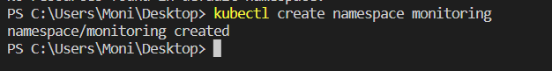

And create the role

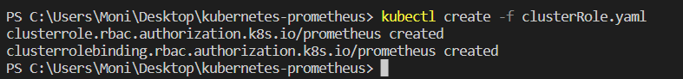

Create the config map in Kubernetes, Create a deployment on monitoring namespace and check the deployment.  
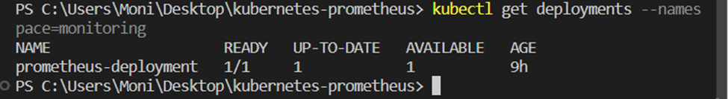

Connecting To Prometheus Dashboard  
  
Using Kubectl port forwarding - Get pods name

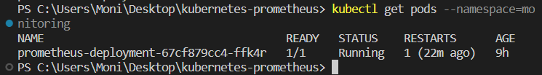

We get the name of the pod and enter the following command

kubectl port-forward prometheus-deployment-67cf879cc4-ffk4r 8081:9090 -n monitoring

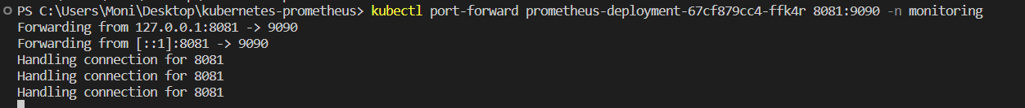

change the port from 8080 to 8081 because it was already in use  
and we can access Prometheus on localhost 8081

Create the service with the command:

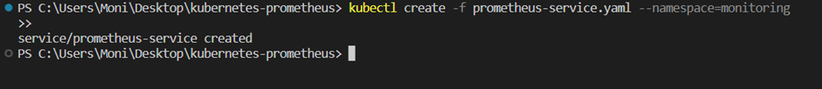

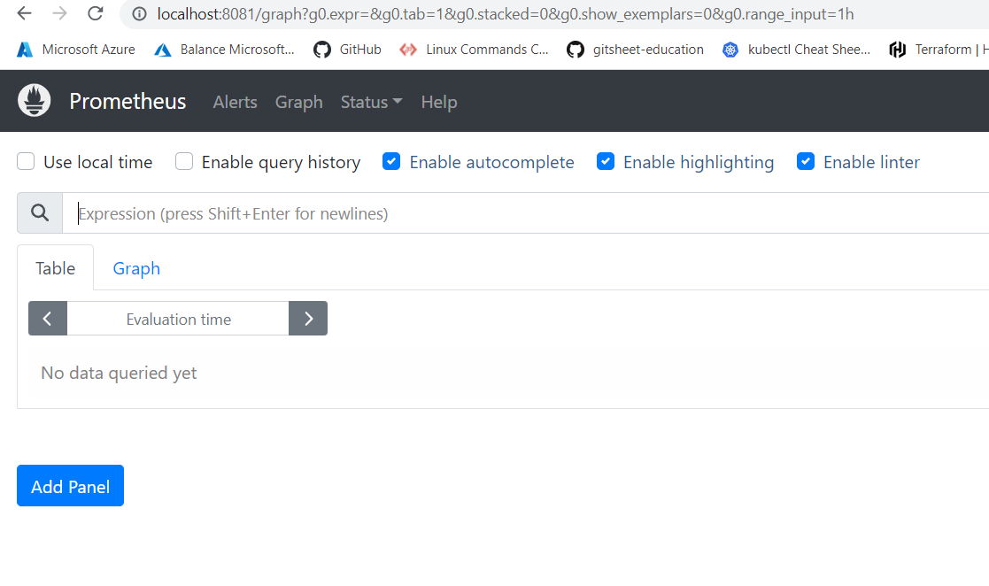  
If you browse to targets you can see the endpoints connected to Prometheus

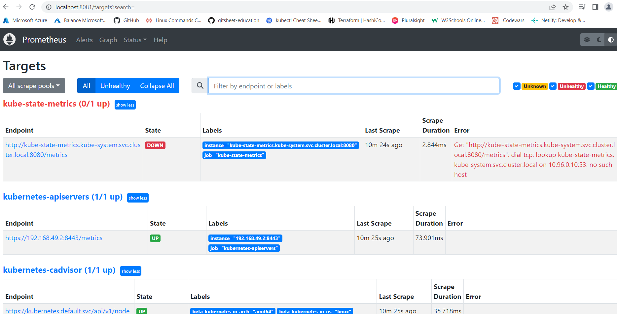

The kube-state-metrics down and it is expected

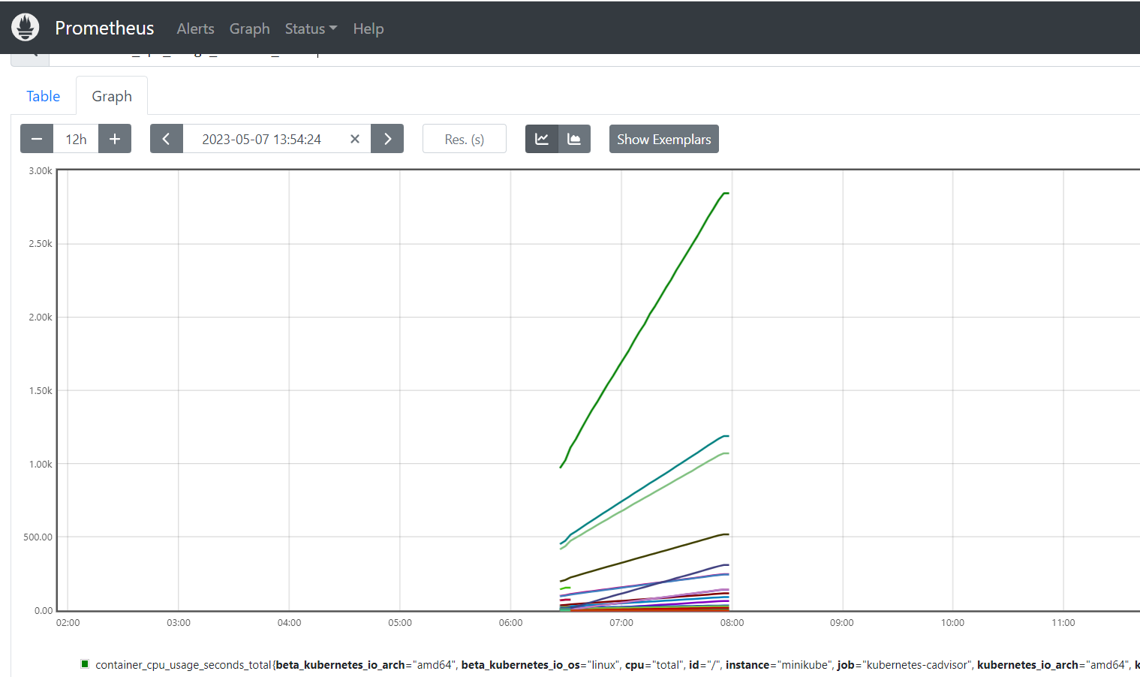

This is a graph for container usage

Exposing the Prometheus deployment as a service with NodePort or a Load Balancer.

Setting Up Alertmanager

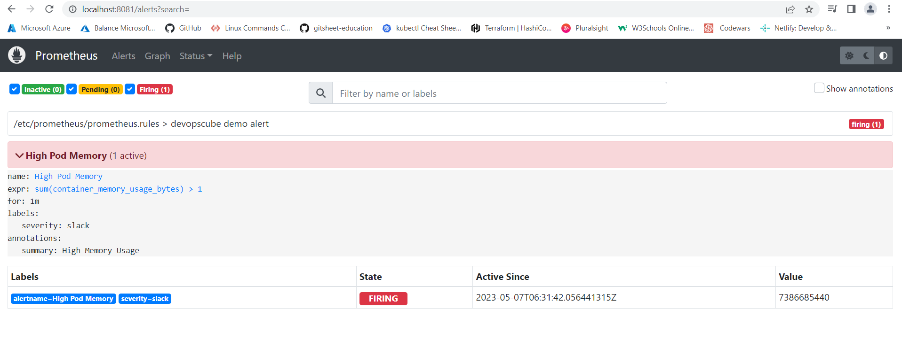

Setting Up Grafana  
Get the yaml files from github repo

Check the node info to get the IP address  


Create the yaml file daemonset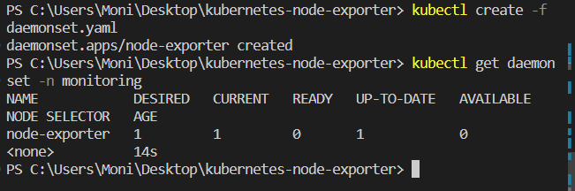

Create a file names service.yaml

Create the service. 

Get the pods info

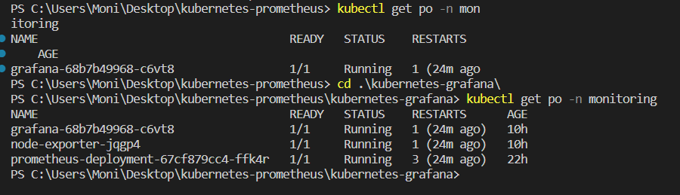

Use port forwarding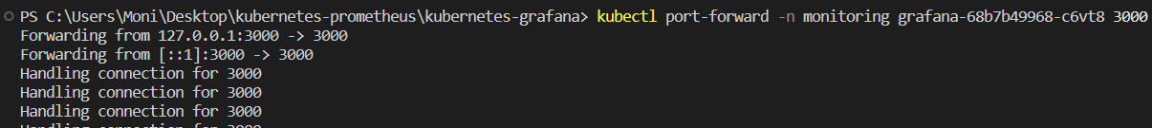

Lon in Grafana

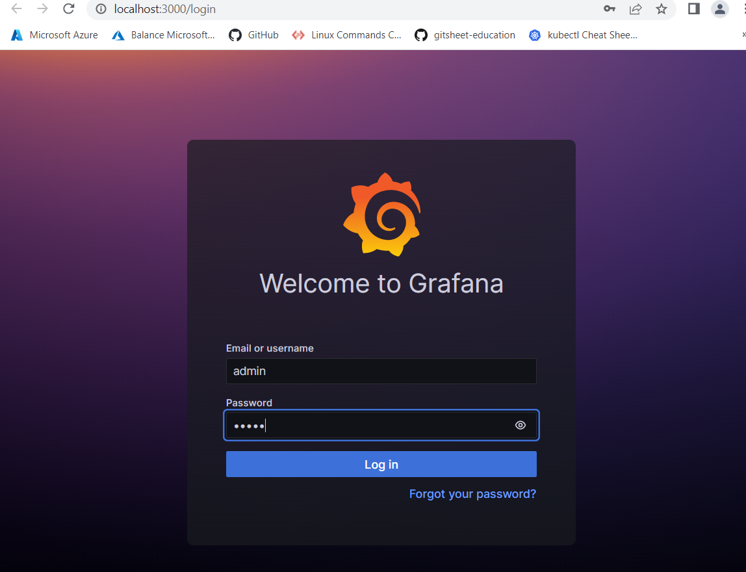

Download the JSON file and import

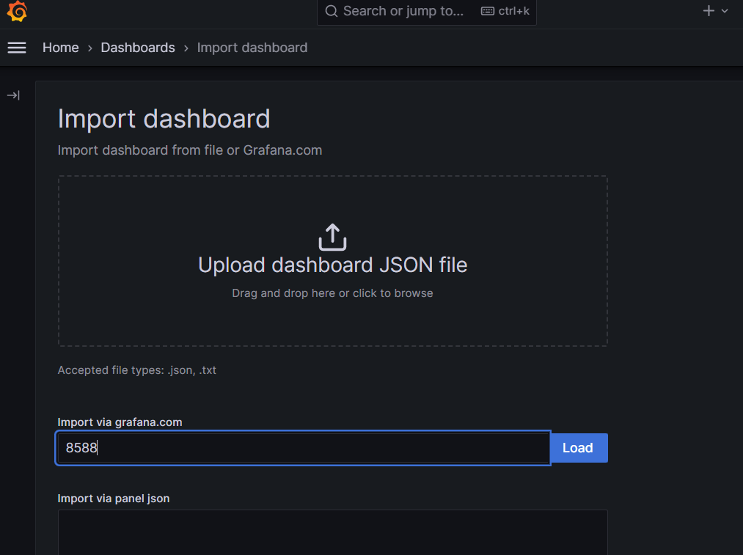

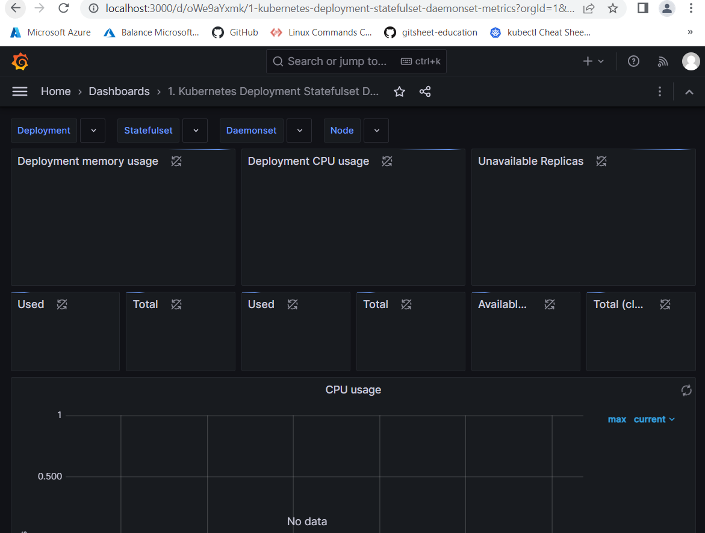

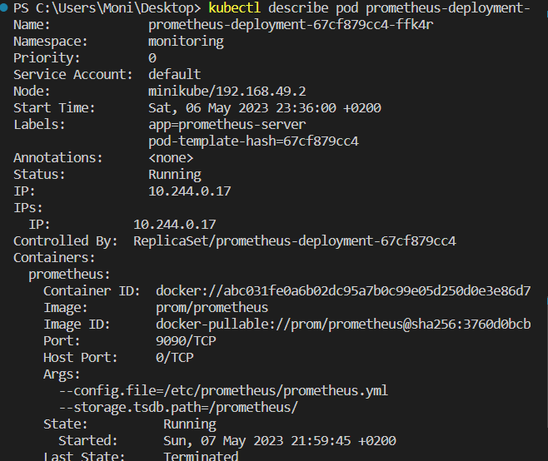

Update Grafana to pull data from prometeus

